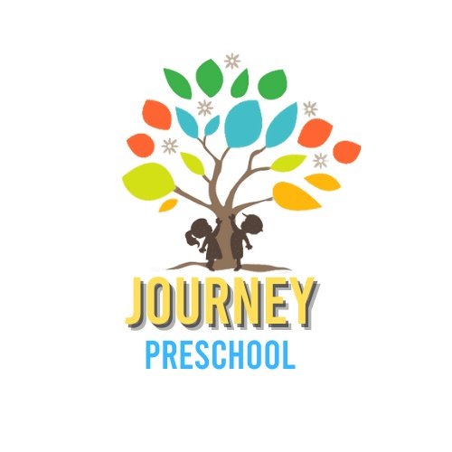
Tuition Contract
School Year 2026–2027

Family Information
Guardian / Parent Name:
Child's Name:
Child's Date of Birth:

Tuition Options — Please select one:
📋 Tuition Payment Policy
All tuition is collected through Brightwheel only. If your family needs a different means of paying, please contact the Director.

✓ | # | Tuition Type | Details
☐ | 1 | WPA / Scholarships | Subsidized tuition through Work Participation Activity (WPA)  or other approved scholarship programs.  Contact the Director to verify eligibility and enrollment.
☐ | 2 | Equicare Grant | Tuition covered through the Equicare Grant program.  Eligibility and award amounts determined by grant guidelines.  Director will confirm coverage details upon enrollment.
☐ | 3 | PreK Grant | Family responsibility: $600.00 for the school year  Before and/or After Care (if applicable): $85.00 / week  Grant covers the standard school day program.  Before/after care costs are in addition to the family portion.
☐ | 4 | Private Tuition | School Day (9:00 AM – 3:30 PM): $300.00 / week (charged bi-weekly — $600.00 every two weeks)  Full Day Care (8:00 AM – 6:00 PM): $385.00 / week (charged bi-weekly — $770.00 every two weeks)  Select the program that applies to your child's schedule.
☐ | 5 | Journey Preschool Scholarship | Full Day Care (8:00 AM – 6:00 PM): $300.00 / week (charged bi-weekly — $600.00 every two weeks)  Awarded based on availability and Director approval.  Scholarship covers full-day care at a reduced rate.

Agreement & Signatures
By signing below, I confirm that I have read and understand the tuition terms for the 2026–2027 school year and agree to make payments as outlined above.
Guardian / Parent Signature |  | Date
Director Signature |  | Date

Journey Preschool • journeypreschoolmd@gmail.com • @journeypreschoolmd • journeypreschoolmd.com

